DOCAYA
Enterprise Electronic Document Management System
Functional & Business Design Specification
Prepared for the Client - United Arab Emirates

Document type | Functional & Business Design (Solution Definition)
Client / Owner | Client, UAE
Platform | Microsoft Azure · Microsoft 365 · SharePoint Online · Entra ID · UAE PASS
Version | 2.0 (enhanced business design)
Status | Draft for Review
Classification | OFFICIAL – Client Internal Use
Date | 4 September 2026

Table of Contents
Table of Contents 1
1. Executive Summary 1
1.1 Business Value for the Client................................................................................................................... 1
1.2 Scope of this Document 1
2. Business Context & Objectives 1
2.1 The Problem Today 1
2.2 Objectives 1
2.3 Alignment to UAE Government Standards 1
3. Personas & Role Model 1
3.1 Personas 1
3.2 Role Hierarchy (RBAC + ABAC) 1
4. Solution Capability Overview 1
5. The Docaya Document Lifecycle — Revised End-to-End Flow 1
5.1 Status State Machine 1
6. Module M1 — Capture & Document Registration 1
6.1 Functional Design 1
6.2 Auto-Populated vs. User-Entered Fields 1
7. Module M2 — Classification & Metadata 1
7.1 Classification Dimensions 1
7.2 Manual Classification Controls................................................................................................................ 1
8. Module M3 — Workflow & Approval 1
8.1 Submission & Routing 1
8.2 Approval Patterns 1
8.3 Decision Handling 1
9. Module M4 — Promotion & Publishing 1
10. Module M5 — Staging Lifecycle & Cleanup 1
11. Module M6 — AI Search & RAG Pipeline 1
11.1 Pipeline Stages 1
11.2 Design Principles 1
12. Module M7 — Notification Center 1
13. Module M8 — Correspondence Management 1
14. Module M9 — Records, Retention & Legal Hold 1
15. Module M10 — Search & Discovery 1
16. Module M11 — Identity, SSO & SharePoint Integration 1
16.1 Single Sign-On with UAE PASS 1
16.2 Governed SharePoint Service Identity 1
17. Module M12 — Access Control (RBAC + ABAC) 1
18. Module M13 — Admin Center 1
19. Module M14 — Reporting & Analytics 1
20. Module M15 — Audit & Compliance 1
21. Reference Architecture 1
21.1 Solution Architecture — Azure & Microsoft Building Blocks........................................................... 1
21.2 Application Architecture — Component View.......................................................................... 1
22. Non-Functional & Compliance Targets 1
23. Delivery Roadmap 1
24. Assumptions, Decisions & Next Steps 1
24.1 Key Design Decisions 1
24.2 Immediate Next Steps 1

1. Executive Summary
Docaya is a full-fledged, government-grade Electronic Document Management System (EDMS) designed to give the Client a single, governed, and intelligent home for every official document — from correspondence, memos, and circulars to contracts, HR records, operational reports, and case files. It applies a controlled capture → classify → approve → promote pipeline so that no document becomes an official record until it has been registered, enriched with metadata, and formally approved.
Docaya does not replace SharePoint Online — it elevates it. SharePoint Online remains the authoritative system of record for approved content and native versioning, while Azure services provide the staging zone, metadata registry, approval orchestration, AI-powered search, notifications, and a tamper-evident audit trail. Identity is unified through UAE PASS single sign-on federated with Microsoft Entra ID, and full Arabic/English (RTL) support is native to the experience.
Design intent Deliver a secure, auditable document lifecycle for the Client in which every document is manually registered and classified by the contributor, tracked in Azure SQL, physically promoted into the correct SharePoint Online library only after approval — in its original file format — and then made discoverable through a Retrieval-Augmented Generation (RAG) search layer on Azure AI Search that operates only over approved, published content.

1.1 Business Value for the Client
Outcome | What Docaya delivers | Measurable target
Governed publishing | 100% of documents pass registration, classification and approval before becoming records | Zero ungoverned uploads to live libraries
Traceability | Every action attributed, time-stamped and audited in Azure SQL | Full chain of custody per document
Findability | AI/RAG semantic + full-text search over approved content | Median time-to-find < 3 seconds
Lifecycle control | Proactive expiry, retention and legal-hold management | Zero uncontrolled expiries
National compliance | Aligned to UAE Information Assurance (IA) standards and data-protection law | Audit-ready at all times
One identity | UAE PASS SSO federated to Entra ID; SharePoint accessed via a governed service identity | Single sign-on, least privilege

1.2 Scope of this Document
This document defines the enhanced business and functional design of Docaya for the Client. It details the revised end-to-end document flow, the complete feature catalogue, the module-by-module functional design, the AI/RAG search pipeline, the identity and SharePoint integration model, and the governance controls. Detailed low-level engineering, infrastructure sizing and code remain in the accompanying technical specification.

2. Business Context & Objectives

2.1 The Problem Today
Across a large organisation, documents are created and shared through email, network drives, chat, and direct uploads to SharePoint with inconsistent metadata and no enforced classification or approval gate. This produces poor findability, weak governance over sensitive material, duplicated records, and no proactive control over document expiry or retention. For a security-sensitive organisation such as the Client, these gaps carry operational, compliance, and reputational risk.

2.2 Objectives
# | Objective | Success measure
O1 | Enforce registration, classification and approval before any document is published | 100% of new documents pass the pipeline
O2 | Provide fast, permission-trimmed, AI-assisted retrieval | Median time-to-find < 3 seconds
O3 | Make the full document lifecycle proactive and auditable | Zero documents expire without prior notification
O4 | Enforce strong, attributable, least-privilege access | Every access decision logged and traceable
O5 | Stay entirely within the trusted Microsoft + UAE PASS ecosystem | One identity, one platform, national compliance
O6 | Support Arabic and English as first-class languages | Full bilingual, RTL-capable experience

2.3 Alignment to UAE Government Standards
- UAE Information Assurance (IA) Standards — controls for classification, access, audit and incident handling.
- UAE Federal Data Protection Law (PDPL) — lawful processing, data-subject rights, and residency within UAE Azure regions, as applicable to the Client’s requirement.
- Client document classification — support for Public, Internal/Restricted, Confidential and Secret handling markings, based on the Client’s requirement.
- UAE PASS — the national digital identity used as the primary single sign-on for all users.

3. Personas & Role Model

3.1 Personas
Persona | Role in Client context | Primary needs
Contributor / Initiator | Officers and staff who create or register documents | Fast capture, guided registration, clear status
Reviewer / Approver | Department heads, managers, delegated approvers | Clear queue, one-click approve/reject with comments
Records & Compliance Officer | Governance, retention, legal hold, audit | Retention control, holds, complete audit visibility
Department Administrator | Configures library routing and metadata for a department | Self-serve, no-code configuration
System Administrator | Runs the platform, identity and integrations | Central control, monitoring, security
Consumer / Viewer | Staff who search and read approved documents | Powerful secure search, permission-trimmed results
Auditor | Read-only oversight of activity and records | Immutable, filterable audit and reporting

3.2 Role Hierarchy (RBAC + ABAC)
Access is governed by Role-Based Access Control (roles/app-roles) combined with Attribute-Based Access Control (department, sensitivity, clearance). Docaya evaluates the effective permission, and SharePoint ACLs remain decisive for the stored content.
Capability | Sys Admin | Records Off. | Dept Admin | Approver | Contributor | Viewer
Configure platform | Full | — | — | — | — | —
Configure dept routing / metadata | Full | — | Scoped | — | — | —
Register / upload document | Full | Full | Full | Full | Full | —
Classify & submit | Full | Full | Full | Full | Full | —
Approve / reject | Full | Scoped | — | Full | — | —
Manage retention / legal hold | Full | Full | — | — | — | —
Search & view (permission-trimmed) | Full | Full | Full | Full | Full | Full
View audit log | Full | Full | Scoped | — | — | —
Legend: Full = full capability · Scoped = limited to assignment · — = denied

4. Solution Capability Overview
Docaya is delivered as an integrated set of functional modules. The table below is the master capability catalogue; each module is designed in detail in Sections 6–15.
# | Module | Core capability
M1 | Capture & Document Registration | Multi-format capture into staging, auto-metadata, unique tracking number, Azure SQL registry
M2 | Classification & Metadata | Manual class, sensitivity, department and approval-flow selection by the contributor; no AI feature at loading, registration or classification
M3 | Workflow & Approval | Configurable single/sequential/parallel approval with SLA and escalation
M4 | Promotion & Publishing | Approved original file promoted to the correct live SharePoint library, versioned
M5 | Staging Lifecycle & Cleanup | Approved/rejected handling, purge or retain policy, published-folder move
M6 | AI Search & RAG Pipeline | Batch indexing into Azure AI Search + grounded 'Ask Docaya' assistant
M7 | Notification Center | Real-time, multi-channel alerts across every lifecycle stage
M8 | Correspondence Management | Incoming/outgoing correspondence, memos, circulars with reference numbers
M9 | Records, Retention & Legal Hold | Retention schedules, disposition, freeze and defensible deletion
M10 | Search & Discovery | Hybrid keyword + semantic + faceted, permission-trimmed
M11 | Identity, SSO & SharePoint Integration | UAE PASS + Entra ID SSO; SharePoint via governed service identity
M12 | Access Control (RBAC + ABAC) | Least-privilege, attribute-aware authorization
M13 | Admin Center | No-code configuration of types, routing, retention, notifications
M14 | Reporting & Analytics | Operational, compliance and lifecycle dashboards
M15 | Audit & Compliance | Tamper-evident audit, IA/PDPL alignment, e-signature

5. The Docaya Document Lifecycle — Revised End-to-End Flow
This is the authoritative, enhanced process for the Client. It replaces the earlier draft flow and reflects the revised business requirements. Each step lists the actor, the system behaviour, the status transition, and where data lives.
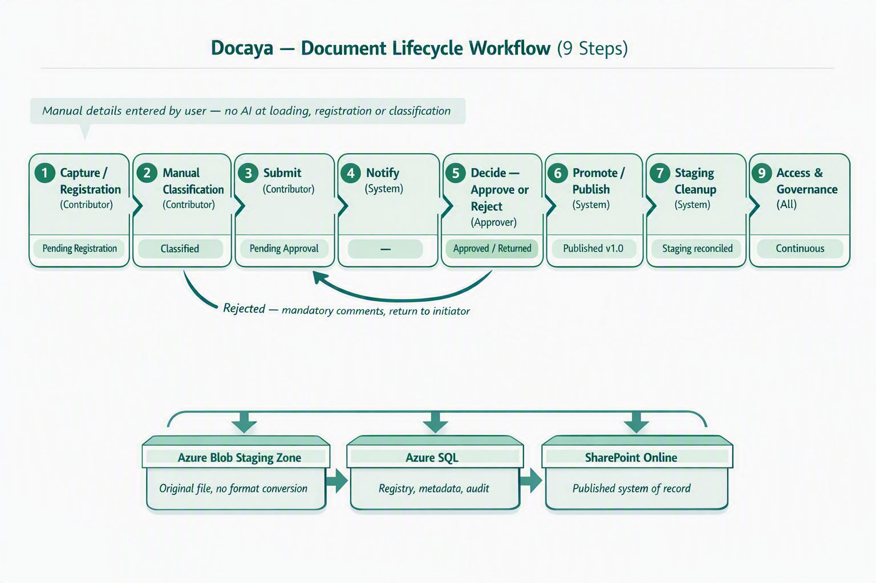  Figure 1 — End-to-end document lifecycle workflow: manual capture and classification, approval-driven promotion in the original file format, and post-publication indexing.  Step |  | Stage | Actor | What happens | Status
1 |  | Capture / Registration | Contributor | The contributor uploads a file (PDF, DOCX, XLSX, PNG, JPEG and other supported types). The original file is stored in the controlled Staging Zone (Azure Blob) — or, where configured, a staging area within a SharePoint site — without converting the file format. A unique tracking number (e.g., DOC-2026-000123) is issued, and a registry row is created in Azure SQL where the document is tracked, monitored and audited. Docaya captures technical attributes such as file name, detected type, size, hash and capture timestamp; the contributor manually completes the required registration fields before the approval flow starts. | Status → PendingRegistration / Draft
2 |  | Classify | Contributor | The contributor manually classifies the document by selecting the document class, sensitivity, owning department and approval flow from Admin-configured values. No AI suggestion, OCR extraction, metadata recommendation or approval recommendation is provided during loading, registration or classification. All classification metadata is written to Azure SQL, and the configured approval flow starts once the required details are complete. | Status → Classified
3 |  | Submit | Contributor | The contributor submits. Classification rules determine the target SharePoint library and the approver(s). The document moves to PendingApproval and appears in the approver's queue. | Status → PendingApproval
4 |  | Notify | System | At every stage the Notification Center alerts the relevant parties in-app and via email / Microsoft Teams — including the approver on submission and the contributor on each decision. | (no status change)
5 |  | Decide | Approver | The approver opens and reviews the document. They either Approve, or Reject/Request-changes with mandatory comments. On rejection the document returns to the initiator (status Classified) for correction and re-submission. | Status → Approved or → Classified (returned)
6 |  | Promote / Publish | System | Immediately on approval, Docaya promotes the original file from staging into the actual SharePoint library path where the document belongs (the final class selected by the contributor). No conversion to another binary or file format is performed; the DOCX, PDF, XLSX, image or other approved format remains unchanged. Durable Functions call Microsoft Graph to upload or move the file stream; the SharePoint Item ID, web URL and version 1.0 are captured back into Azure SQL. | Status → Published (v1.0)
7 |  | Cleanup | System | The staging copy is handled per policy — purged, or moved to a dedicated 'Published/Approved' folder within staging for retention. The contributor is notified of successful publication. | Staging reconciled
8 |  | Index (RAG Pipeline) | System (batch) | A scheduled batch process runs the RAG pipeline: it enriches and chunks published documents and their Azure SQL metadata, generates embeddings, and feeds Azure AI Search. This index powers the in-app AI search and 'Ask Docaya' assistant over the documents registered in Azure SQL and stored in SharePoint. | Indexed & searchable
9 |  | Access & Governance | All | Users access Docaya via UAE PASS single sign-on federated to Entra ID. Access is managed inside Docaya, while the platform reaches SharePoint through a governed service identity that holds read/write on the document estate. This keeps user permissions centralised in Docaya while all content operations occur under one auditable service principal. | Continuous
 | Key promotion rule The original file remains in its native format in staging throughout capture, classification and approval. Only on approval is the same file promoted into the correct live SharePoint Online library and given version 1.0 — at which point it becomes an official Client record.

5.1 Status State Machine
State | Meaning | File location
Draft / PendingRegistration | Uploaded; auto-metadata populated; registration fields being completed | Staging (Blob / SP staging)
Classified | Class, sensitivity, department, approver flow selected | Staging
PendingApproval | Submitted; awaiting approver decision | Staging
Returned | Rejected with mandatory comments; back with initiator | Staging
Approved | Approver signed off; promotion pending | Staging (transient)
Published | Promoted to SharePoint library; version 1.0 | SharePoint Online
Superseded | Replaced by a newer approved version | SharePoint Online
Expiring | Within the expiry notification window | SharePoint Online
Archived / Disposed | Retention reached; archived or defensibly deleted | Archive / removed per policy

6. Module M1 — Capture & Document Registration

6.1 Functional Design
- Multi-format capture: PDF, DOCX, XLSX, PPTX, PNG, JPEG/JPG, TIFF and other approved MIME types, validated by both extension and file signature.
- Multiple capture channels: drag-and-drop (single & bulk), scan-to-PDF, and email-in to a per-department address (roadmap).
- Resumable, chunked upload for large files (up to 5 GB) with progress, cancel and retry.
- Staging-first storage: the original file is written to the Azure Blob Staging Zone (or a SharePoint staging area where configured) in the same format — never directly to a live library and never converted to another format.
- Unique tracking number issued at capture in the format DOC-YYYY-NNNNNN, printed on screen and used across the whole lifecycle.
- Azure SQL registry row created immediately; the document is tracked, monitored and audited from this moment, with an initial status.
- Content integrity: a SHA-256 hash is computed for de-duplication and tamper detection; malware and DLP checks run before the item can proceed.

6.2 Auto-Populated vs. User-Entered Fields
On the registration screen Docaya auto-detects and pre-fills technical attributes; the contributor supplies the business context.
Auto-populated by Docaya (technical attributes) |  | Entered manually by the contributor
Document name (from file, editable) |  | Business title / subject
Detected document type / MIME |  | Document class (see M2)
File size and page count |  | Owning department
Content hash (SHA-256) |  | Sensitivity / handling marking
Capture timestamp & channel |  | Description / keywords / reference
Tracking number (DOC-YYYY-NNNNNN) |  | Retention / expiry hints (optional)
Uploader role / authenticated user reference |  | Approver flow selection
 | Registration = accountability The Azure SQL registry is the single source of truth for chain of custody. From the instant a tracking number is issued, every view, edit, decision and movement is recorded against it.

7. Module M2 — Classification & Metadata
Classification is contributor-driven and rules-aware. The contributor selects all required values manually from Admin-configured dropdowns. No AI feature is available during loading, registration or classification; AI/RAG is applied later, only to approved and published content.

7.1 Classification Dimensions
Dimension | Purpose | Example values
Document class | Determines target library & schema | Correspondence, Memo, Circular, Contract, HR Record, Report, Policy
Sensitivity / handling | Drives access & approval routing | Public, Internal, Confidential, Secret
Owning department | Ownership & routing | e.g., Finance, HR, Legal, Operations
Priority | Queue ordering & SLA | Routine, Priority, Urgent
Approval flow | Selects approver chain | Single, Sequential, Parallel
Access scope (ABAC) | Attribute-based restriction | Department-only, Named group, Clearance level

7.2 Manual Classification Controls
- No AI at registration: Docaya does not provide AI-generated classification, metadata extraction, OCR suggestions or approval recommendations during document loading, registration or classification.
- Manual details required: the contributor manually enters or selects the business title, document class, sensitivity, owning department, description, keywords/reference and approval flow.
- Schema validation: metadata is validated against the configurable document-type schema before submission is allowed.
- Approval-flow enforcement: once the manual details are complete, Docaya routes the document through the configured approval flow.
- Azure SQL persistence: classification, workflow status, audit trail and SharePoint promotion references are fully auditable and reportable.

8. Module M3 — Workflow & Approval

8.1 Submission & Routing
On submission, classification rules resolve the target SharePoint library and the approver(s). The document enters PendingApproval and is placed on the approver's queue with full context and preview.

8.2 Approval Patterns
Pattern | Behaviour | Typical use
Single | One approver decides | Routine internal documents
Sequential | Approvers act in order; each must approve to proceed | Confidential / multi-level sign-off
Parallel | Multiple approvers in parallel; quorum or unanimous | Cross-department documents
Conditional | Route by rule (e.g., sensitivity = Secret → senior + compliance) | Sensitive or high-value records

8.3 Decision Handling
- Approve: the document is marked Approved and immediately promoted (Module M4) to the final class/library selected by the contributor.
- Reject / Request changes: mandatory comments (more information) are required; the document returns to the initiator as Returned/Classified for correction and re-submission.
- SLA & escalation: each approval task carries an SLA timer; on breach it escalates to the configured delegate or manager and raises a notification.
- Act anywhere: approvers can decide from the in-app queue, email action buttons, or Microsoft Teams.
- Delegation: out-of-office auto-reassignment keeps the queue moving.
Mandatory rejection reason A rejection cannot be submitted without comments. This guarantees the initiator always receives actionable feedback and preserves a complete decision record in the audit trail.
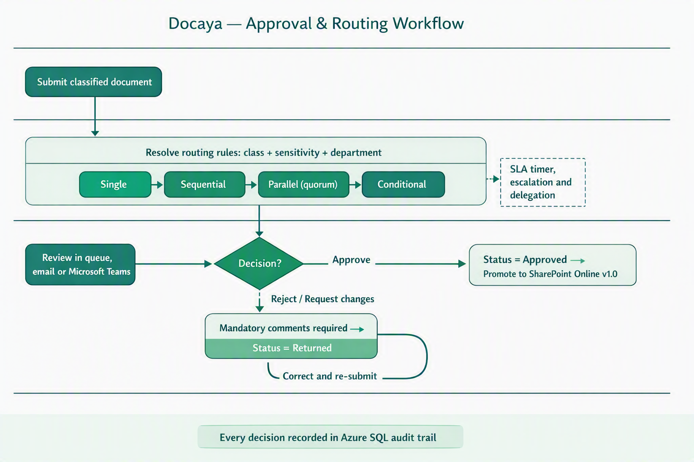
Figure 2 — Approval and routing workflow: rule-based routing, the four approval patterns, SLA escalation and the mandatory-comment return path.

9. Module M4 — Promotion & Publishing
- Immediate promotion: on approval, Durable Functions orchestrate the move from staging into the correct live SharePoint library path for the document's final class.
- Microsoft Graph upload transfers the original file stream without changing the file format; SharePoint's native versioning assigns version 1.0.
- Write-back to Azure SQL: SharePoint Item ID, Drive/Library ID, web URL and version label are captured on the registry row, linking record and content.
- Idempotent promotion: an idempotency key ensures a retry can never create a duplicate SharePoint item.
- Native versioning thereafter: subsequent approved edits create new SharePoint versions (2.0, 3.0 …); Docaya records the version label.
- Failure safety: if promotion fails, the item remains recoverable and visible in staging; the original file is never lost.

10. Module M5 — Staging Lifecycle & Cleanup
Situation | Cleanup behaviour
Document published | Staging copy of the original file purged, OR moved to a dedicated 'Published / Approved' folder in staging per retention policy
Document rejected / returned | Original file retained in staging under the initiator until corrected and re-submitted
Abandoned draft | Auto-expiry after a configurable period, with owner notification before removal
Failed promotion | Original file retained and flagged for operational replay via idempotent retry
- Lifecycle rules on the staging container keep storage costs controlled while preserving auditability.
- Contributor notified of successful publication with a direct link to the SharePoint record.

11. Module M6 — AI Search & RAG Pipeline
A scheduled batch process builds and maintains a Retrieval-Augmented Generation (RAG) index using Azure AI Search. It draws on both the document metadata registered in Azure SQL (all information the initiator and approver entered on screen) and the published content in SharePoint, enabling the AI search and 'Ask Docaya' assistant inside the application.

11.1 Pipeline Stages
Stage | Action | Output
1 · Collect | Batch job selects newly published / updated documents from Azure SQL | Work list with tracking numbers
2 · Extract | Retrieve text (OCR where needed) and metadata fields | Normalised text + structured metadata
3 · Chunk | Split content into overlapping, context-preserving chunks | Chunk set per document
4 · Embed | Generate vector embeddings (Azure OpenAI) | Vectors per chunk
5 · Index | Upsert vectors + metadata + ACL trimming keys into Azure AI Search | Searchable, permission-aware index
6 · Serve | App queries hybrid (keyword + vector) with security filters; 'Ask Docaya' returns cited answers | Grounded, permission-trimmed results

11.2 Design Principles
- Grounded & cited: 'Ask Docaya' answers only from indexed Client documents the user is permitted to see, with source citations back to the exact document/version.
- Permission-trimmed retrieval: every query carries the user's effective ACL keys; the index never returns content the user cannot access.
- Metadata + content fusion: because all registration data lives in Azure SQL, search can combine structured filters (department, class, sensitivity, date) with semantic relevance.
- Batch cadence: configurable schedule (e.g., near-real-time micro-batches or scheduled runs) with full re-index capability.
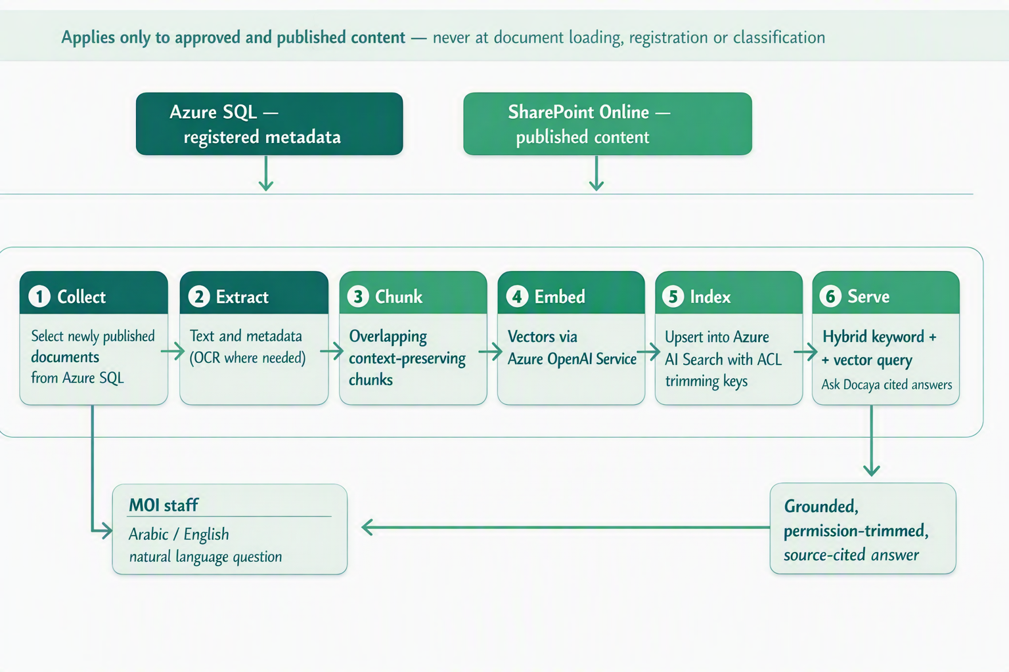
Figure 3 — Batch RAG indexing and search pipeline, applied only to approved and published content.
Why RAG for the Client RAG turns the approved document estate into an answerable knowledge base: staff ask natural-language questions in Arabic or English and receive concise, source-cited answers drawn only from published documents they are authorised to view. It is never applied at document loading, registration or classification.

12. Module M7 — Notification Center
The Notification Center is a first-class surface that keeps every actor informed at every lifecycle stage, with zero noise.
Category | Examples | Default channels
Workflow | Approval requested, approved, rejected, SLA breach, escalation | In-app, Email, Teams
Registration | Document registered, submitted, returned for changes | In-app, Email
Publication | Successfully promoted to SharePoint, new version | In-app, Email
Expiry / Lifecycle | T-30 / T-7 / T-1 day reminders, retention due | In-app, Email
Security | Permission change, unusual access, external share (locked, mandatory) | In-app, Email, Push
System | Storage, maintenance, batch/index status | In-app, Email
- Real-time delivery via Azure SignalR; durable history retained in Azure SQL.
- Per-user preferences per notification type and channel; security notifications are mandatory and non-disable-able.
- Smart batching, DND windows and de-duplication prevent alert fatigue; delivery via email (ACS) and Teams/Outlook (Graph).

13. Module M8 — Correspondence Management
Client organisations run on correspondence. Docaya adds a dedicated correspondence capability on top of the core pipeline, designed to support the Client’s day-to-day operational requirement.
- Incoming & outgoing correspondence captured with a formal reference number, sender/recipient, subject and due date.
- Memos & circulars with structured templates, distribution lists and read-acknowledgement tracking.
- Linking & threading relate a reply to its original correspondence to preserve the full thread.
- Routing & action tracking assign, forward, and track actions with due dates and escalation.
- Bilingual Arabic/English correspondence with RTL layout.

14. Module M9 — Records, Retention & Legal Hold
Capability | Design
Retention schedules | Time-based or event-based policies per document class, aligned to the Client's records policy
Disposition | Auto-archive, review-then-delete, or defensible permanent deletion with approval
Legal hold | Overrides retention; freezes documents, blocks deletion, fully audited
Records declaration | Freeze metadata + content for compliance / evidential integrity
Archive tiering | Move cold records to archive storage while preserving the registry link
Data residency | All data pinned to UAE Azure regions to satisfy PDPL and IA requirements

15. Module M10 — Search & Discovery
- Hybrid search: BM25 keyword fused with semantic vector relevance for precision and recall.
- Faceted filters: class, department, sensitivity, owner, date, status, tracking number.
- Permission-trimmed: results always honour the user's effective rights (no unauthorised results).
- Ask Docaya: natural-language Q&A grounded in permitted documents, with citations (Module M6).
- Saved searches & smart views for recurring departmental queries.

16. Module M11 — Identity, SSO & SharePoint Integration

16.1 Single Sign-On with UAE PASS
- UAE PASS as primary identity: users sign in with the UAE national digital identity, federated to Microsoft Entra ID for the Docaya application.
- Standards-based: OIDC + PKCE for the single-page app; MFA and Conditional Access enforced by Entra.
- Step-up authentication for sensitive actions such as approving Secret documents or changing permissions.

16.2 Governed SharePoint Service Identity
Docaya integrates with SharePoint through a single governed service identity (system/service principal) that holds read and write access across the Docaya document estate. Once a user signs in to Docaya, their access is managed within Docaya (RBAC + ABAC), while all content operations against SharePoint are performed under this one auditable service identity.
Aspect |  | Design decision | Benefit
User access |  | Centrally managed inside Docaya (roles + attributes) | Single, consistent control point
SharePoint access |  | Performed by the Docaya service identity (read/write on the estate) | Uniform, auditable content operations
Credential |  | Managed identity / workload identity — no stored user passwords | Least-privilege, no secret sprawl
Authorization |  | Docaya enforces who can see/do what before any SharePoint call | Defence in depth
Audit |  | Every action attributed to the real user in Azure SQL, executed by the service identity | Full accountability
 | Integration model Users never touch SharePoint permissions directly. Docaya is the governance layer: it decides access, then acts on SharePoint Online through one controlled Entra ID service identity — keeping permission management simple, centralised and fully audited.

17. Module M12 — Access Control (RBAC + ABAC)
- RBAC: roles/app-roles (Section 3) grant baseline capabilities.
- ABAC overlays: attributes such as department, sensitivity and clearance refine access (e.g., 'Confidential HR records visible to HR only').
- Deny-by-default: no access unless explicitly granted; every decision is logged.
- Effective-permission evaluation combines role + attribute + document scope before any read, download or action.

18. Module M13 — Admin Center
A no-code control plane so Client administrators configure the system without engineering tickets.
Area | Configurable items
Document types & schemas | Create/edit classes, metadata fields, validation, controlled vocabularies
Routing rules | Map class + sensitivity + department to target library and approvers
Workflows | Design single/sequential/parallel/conditional flows; SLA & escalation
Notifications | Templates (Arabic/English), default channels, quiet hours
Retention & legal hold | Schedules, dispositions, holds
Security | MFA enforcement, session policy, step-up rules, IP allowlists
Branding & localisation | Client branding, bilingual labels, RTL defaults
Integrations | Service identity, connectors, webhooks, API keys

19. Module M14 — Reporting & Analytics
- Operational dashboards: documents registered, pending approvals, cycle time, SLA compliance, promotion backlog.
- Compliance dashboards: documents under retention, upcoming dispositions, active legal holds, access anomalies.
- Departmental analytics: volume by class, sensitivity distribution, most-accessed records, stale content.
- Scheduled reports & exports (PDF/XLSX/CSV) and an access-report builder for audits.

20. Module M15 — Audit & Compliance
- Tamper-evident audit: every action (register, classify, submit, decide, promote, view, download, permission change) recorded in a hash-chained Azure SQL audit log.
- Full attribution: actor, action, object, tracking number, timestamp, request ID, source IP and outcome.
- e-Signature: native or integrated e-signature for approvals requiring signed sign-off, with certificate of completion.
- Standards alignment: designed for UAE IA standards, PDPL, ISO 27001 and records-management best practice, as required by the Client.

21. Reference Architecture
The architecture has been revalidated against the updated functional flow: manual registration and classification with no AI at document loading, no file-format conversion between staging and publication, and approval-driven promotion into SharePoint Online. Every component below is a native Azure or Microsoft 365 service — no third-party platform is required. The staging-first promotion path is the backbone of the governed lifecycle.

21.1 Solution Architecture — Azure & Microsoft Building Blocks
Layer | Microsoft / Azure service | Role in the updated flow
Experience | Azure Static Web Apps / Azure App Service, Microsoft Teams & Outlook surfaces | Bilingual (AR/EN, RTL) web client for upload, manual registration form, approver queue and search
Identity | UAE PASS federated to Microsoft Entra ID; Entra managed identity | SSO, MFA and Conditional Access for users; secretless service identity for SharePoint operations
API & gateway | Azure API Management, Azure Front Door / Application Gateway (WAF) | Secure entry point, throttling, token validation and routing to Docaya services
Application | Azure App Service / Azure Container Apps | Registration, classification, workflow, admin, notification and search services (M1–M15)
Orchestration | Azure Durable Functions, Azure Service Bus | Approval routing, SLA timers, escalation and idempotent promotion of the original file
Staging store | Azure Blob Storage (private endpoint) or a configured SharePoint staging area | Holds the file in its original format until approval; no conversion, lifecycle rules for cleanup
Registry & audit | Azure SQL Database | Tracking number, manually entered metadata, status, approval decisions and hash-chained audit
System of record | SharePoint Online via Microsoft Graph | Final library for the approved original file, native versioning from v1.0
Search (post-publish) | Azure AI Search + Azure OpenAI Service (batch RAG) | Indexes approved content only — never invoked during loading, registration or classification
Notifications | Azure SignalR Service, Azure Communication Services, Microsoft Graph (Teams/Outlook) | Real-time in-app alerts plus email and Teams delivery at every lifecycle stage
Security & ops | Azure Key Vault, Microsoft Defender for Cloud, Microsoft Purview, Azure Monitor & Log Analytics | Key management, threat protection, classification/DLP, observability and IA/PDPL evidence
Analytics | Microsoft Power BI on Azure SQL | Operational, compliance and lifecycle dashboards (M14)

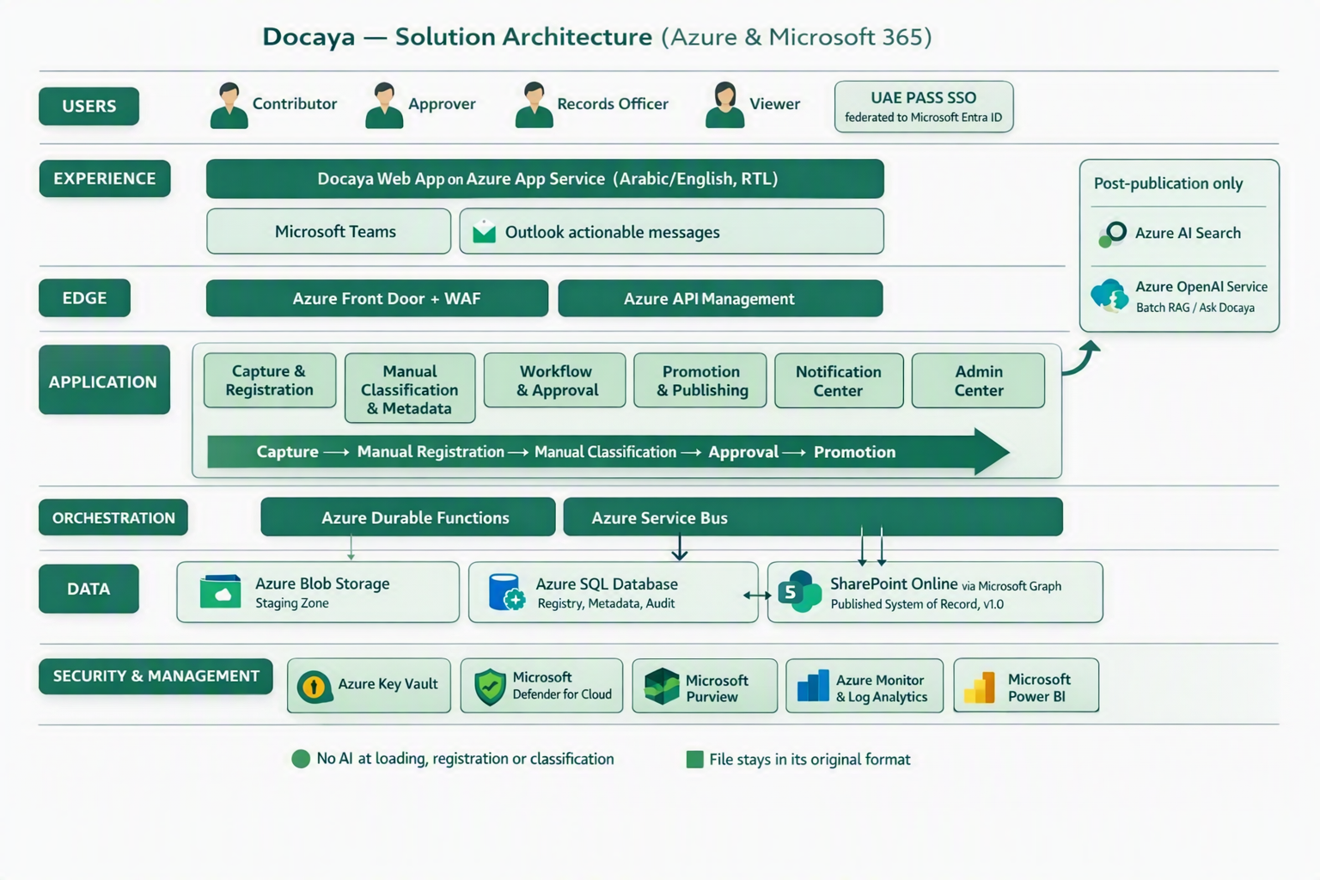
Figure 4 — Docaya solution architecture on Azure and Microsoft 365: staging-first capture, manual registration and classification, approval-driven promotion in the original file format, and AI/RAG applied only after publication.

21.2 Application Architecture — Component View
Component | Responsibility | Depends on
Capture & Registration Service (M1) | Chunked upload, format and signature validation, SHA-256 hash, tracking number, registry row | Azure Blob Storage, Azure SQL, Defender for Storage
Classification Service (M2) | Serves Admin-configured dropdowns, validates the manually entered metadata against the type schema — no AI inference | Azure SQL, Admin Center configuration
Workflow Engine (M3) | Resolves the configured approval flow, manages SLA timers, escalation and delegation | Azure Durable Functions, Service Bus, Azure SQL
Promotion Service (M4) | Idempotent transfer of the original file stream to the target library and write-back of item ID, URL and version | Microsoft Graph, SharePoint Online, Entra managed identity
Staging Lifecycle Service (M5) | Purge, retain or move the staging copy after publication; replay failed promotions | Azure Blob lifecycle rules, Azure Functions
RAG Indexing Service (M6) | Scheduled batch enrichment, chunking, embedding and indexing of published documents only | Azure AI Search, Azure OpenAI Service, SharePoint Online, Azure SQL
Notification Service (M7) | Event fan-out, batching, quiet hours and multi-channel delivery | Azure SignalR, Azure Communication Services, Microsoft Graph
Access Control Service (M12) | Evaluates RBAC + ABAC effective permission before any read, download or content operation | Microsoft Entra ID, Azure SQL policy store
Admin, Reporting & Audit (M13–M15) | No-code configuration, dashboards and tamper-evident audit trail | Azure SQL, Power BI, Azure Monitor, Microsoft Purview

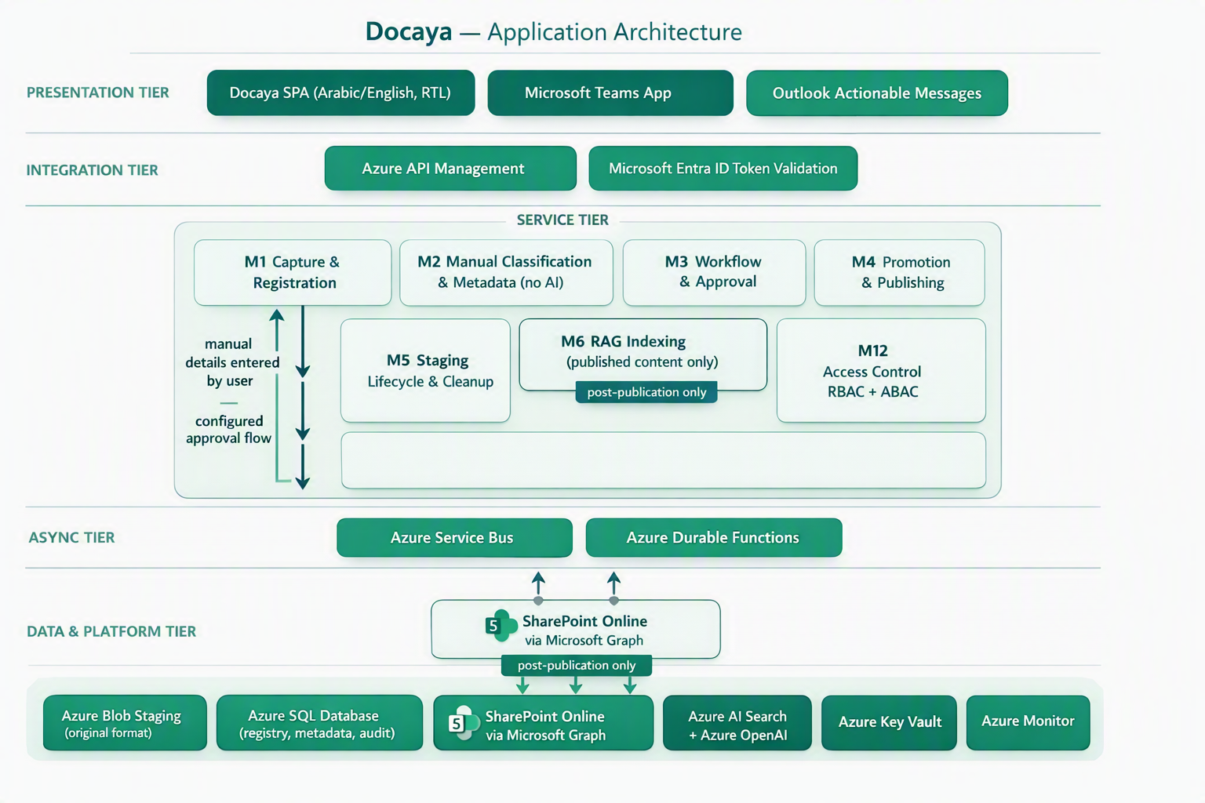
Figure 5 — Docaya application architecture: presentation, integration, service, asynchronous and data tiers across Azure and Microsoft 365.

22. Non-Functional & Compliance Targets
Attribute | Target
Availability | 99.9% baseline (higher tier by service design)
Page load | p95 < 1.5 seconds
Search latency | p95 < 400 ms (permission-trimmed)
Max file size | Up to 5 GB (resumable, chunked)
Recovery | RPO ≤ 5 minutes · RTO ≤ 1 hour
Accessibility | WCAG 2.2 AA; Arabic & English (RTL)
Data residency | UAE Azure regions only
Security | UAE IA standards, PDPL, ISO 27001 alignment; zero-trust, least privilege

23. Delivery Roadmap
Phase | Scope | Indicative timeline
MVP | UAE PASS SSO, capture→staging, classification, approval, promotion, versioning | Months 1–5
V1 | Notification Center, Admin Center, correspondence, search, reporting | Months 5–8
V2 | AI/RAG search & Ask Docaya, retention/legal hold, analytics, integrations | Months 9–12

24. Assumptions, Decisions & Next Steps

24.1 Key Design Decisions
ID | Decision | Status
D1 | SharePoint Online remains the published system of record | Accepted
D2 | All content follows staging → classify → approve → promote | Accepted
D3 | UAE PASS federated to Entra ID is the primary SSO | Accepted
D4 | SharePoint accessed via one governed service identity; user access managed in Docaya | Accepted
D5 | AI search delivered via a batch RAG pipeline on Azure AI Search | Accepted
D6 | Azure SQL is the authoritative registry, audit and metadata store | Accepted

24.2 Immediate Next Steps
- Confirm the Client's document classes, sensitivity markings and departmental library map.
- Finalise UAE PASS ↔ Entra ID federation and the SharePoint service-identity permission scope.
- Approve the retention schedule and legal-hold policy with Records & Compliance.
- Configure the approval routing rules per class and sensitivity in the Admin Center.
- Stand up the RAG pipeline batch cadence and validate permission-trimmed retrieval.
- Run an end-to-end pilot (capture → publish → search) with one department before rollout.
Review outcome required Endorse the revised 9-step lifecycle, the manual classification model, the no-format-conversion promotion rule, the UAE PASS + service-identity integration, and the revalidated Azure/Microsoft reference architecture so build can proceed against this baseline.
— End of Document —

